Assignment (N+) Day-4(Subnets)
Task-1:
Subnet 1:
Network Address: 192.168.10.0
Broadcast Address: 192.168.10.63
Subnet 2:
Network Address: 192.168.10.64
Broadcast Address: 192.168.10.127
Subnet 3:
Network Address: 192.168.10.128
Broadcast Address: 192.168.10.191
Subnet 4:
Network Address: 192.168.10.192
Broadcast Address: 192.168.10.255

Task-2:
Router: 192.168.10.1
Laptop 1: 192.168.10.2
Laptop 2: 192.168.10.3
Printer: 192.168.10.4
Mobile: 192.168.10.5

Task-3:
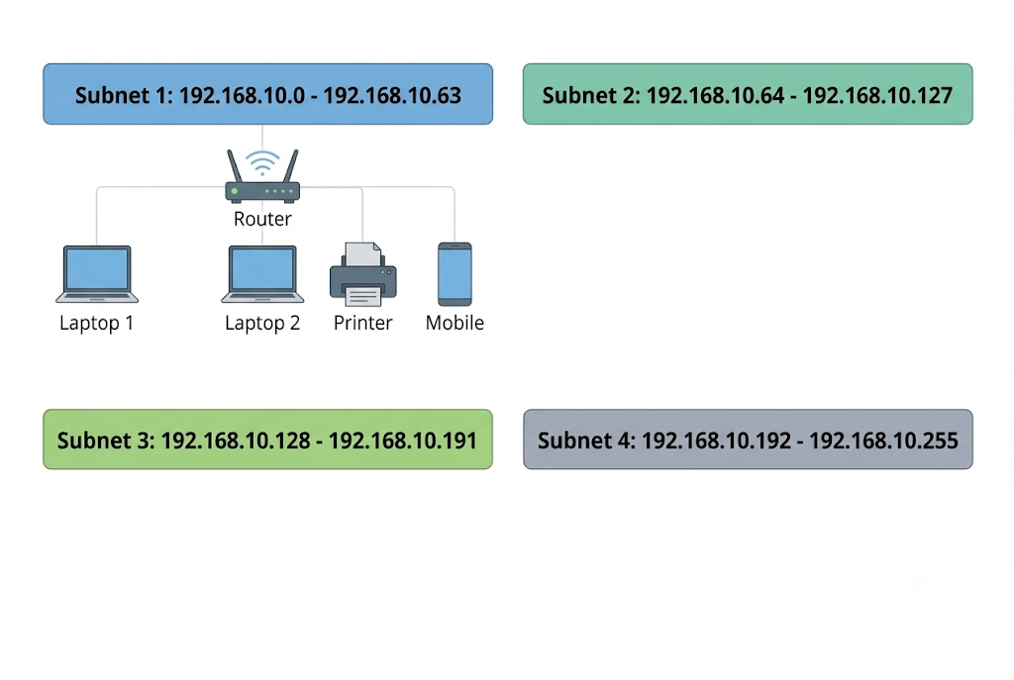

Task-4:
Step 1: Find the New Subnet Mask
- We are starting with a /24 network.
- We need to create 4 equal subnets. To get 4, we need to borrow 2 bits (because 2^2 = 4).
- We add these 2 borrowed bits to our original 24. This gives us a new subnet mask of /26.
- In decimal numbers, a /26 mask is written as 255.255.255.192.
Step 2: Find the Number of Hosts (Devices)
- An IP address has a total of 32 bits.
- Since our new network uses 26 bits, we have 6 bits left for the hosts (32 - 26 = 6).
- To find the total IPs, we calculate 2^6 (2 multiplied 6 times), which gives us 64 total IPs.
- Every subnet wastes 2 addresses (the first is the Network Address and the last is the Broadcast Address).
- So, 64 - 2 = 62. We have exactly 62 usable IP addresses for our devices in each subnet.
Step 3: Write the Subnet Range
- Because our subnet block size is 64, the addresses will jump by 64.
- Our first subnet starts from 192.168.10.0 and ends at 192.168.10.63.
- The Network Address is 192.168.10.0.
- The Broadcast Address is 192.168.10.63.
Step 4: Assign IPs to Devices
- For our devices, we can only use the free addresses in between (from .1 to .62).
- We give the very first address to the Router: 192.168.10.1
- Then, we give the next IPs to the rest of the devices in order:
  - Laptop 1: 192.168.10.2
  - Laptop 2: 192.168.10.3
  - Printer: 192.168.10.4
  - Mobile: 192.168.10.5

